Top down processing

The cognitive system is organized hierarchically. The most basic perceptual systems are located at the bottom of the hierarchy, and the most complex cognitive (e.g. memory, problem solving) systems are located at the top of the hierarchy.

Information can flow both from the bottom of the system to the top of the system and from the top of the system to the bottom of the system. When information flows from the top of the system to the bottom of the system this is called "top-down processing", which is sometimes known as "theory-driven processing".

The implications of this top to bottom flow of information is that information coming into the system (perceptually) can be influenced by what the individual already knows (as information about past experiences are stored in the higher levels of the system).

Top-down Processing is an important perceptual theory in cognitive psychology. The theory establishes that sensory information processing in human cognition, such as perception, recognition, memory, and comprehension, are organized and shaped by our previous experience, expectations: It is also known as "large chunk" processing and states that we form perceptions (or focus our attention) by starting with the larger concept or idea (it can even be the concept or idea of an object) and then working our way down to the finer details of that concept or idea.

Bottom-up processing

This is the opposite of Bottom-Up Processing. Bottom-up processing is also known as "small chunk" processing and suggests that we attend to or perceive elements by starting with the smaller, more fine details of that element and then building upward until we have a solid representation of it in our minds.

Example:

Top down- a man sees a spider and stomps on it because of his past experiences with spiders. Bottom up- a man feels a something crawling on his arm and, without seeing it, freaks out.

Comics and cartoons provide many examples of top-down processing. Simple cues are used to suggest complex feelings and emotions.

Feedback network

Spacial or temporal summation EPSP

[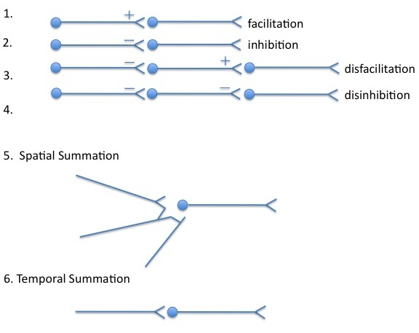](http://upload.wikimedia.org/wikipedia/commons/7/79/Interneuronalrelations.jpg)

Spatial summation

It is a way of achieving an [action potential](http://en.wikipedia.org/wiki/Action_potential) in a [neuron](http://en.wikipedia.org/wiki/Neuron) which involves input from multiple presynaptic cells. Spatial summation is the algebraic summation of potentials from different areas of input, usually on the [dendrites](http://en.wikipedia.org/wiki/Dendrites). Summation of [excitatory postsynaptic potentials](http://en.wikipedia.org/wiki/Excitatory_postsynaptic_potentials) allows the potential to reach the [threshold](http://en.wikipedia.org/wiki/Sensory_threshold) to generate an action potential, whereas [inhibitory postsynaptic potentials](http://en.wikipedia.org/wiki/Inhibitory_postsynaptic_potentials) can prevent the cell from achieving an action potential

Temporal summation

It is another means of transmitting signals. A potential begins before a previous one ends. The amplitude of the previous potential at the point where the second begins will algebraically summate, generating a potential that is overall larger than the individual potentials. This allows the potential to reach the [threshold](http://en.wikipedia.org/wiki/Sensory_threshold) to generate an action potential.

Lateral inhibition

It is the capacity of an excited [neuron](http://en.wikipedia.org/wiki/Neuron) to reduce the activity of its neighbors. Lateral inhibition sharpens the spatial profile of excitation in response to a localized stimulus.

[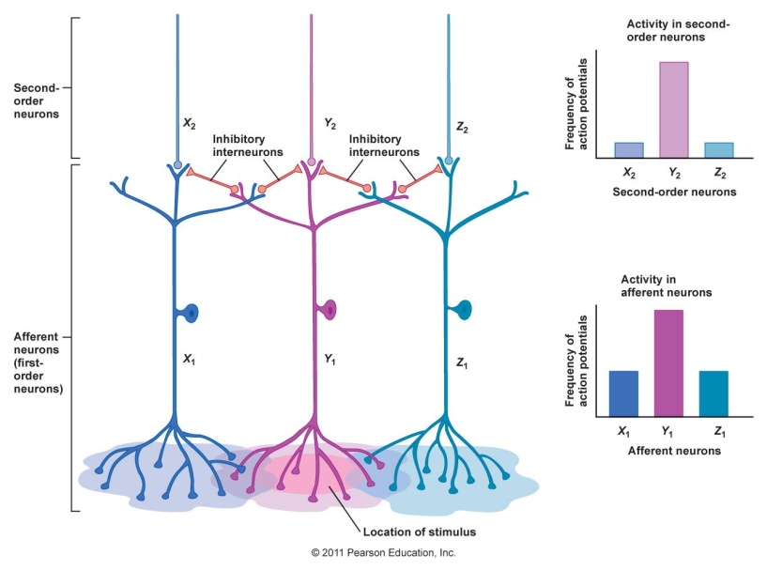](http://www.google.ca/url?sa=i&source=images&cd=&cad=rja&docid=bxMnFfR584VO-M&tbnid=qQHpYSxFbsQD4M:&ved=0CAgQjRwwAA&url=http://211.174.114.20/word.asp?no=13125&ei=3QxKUeeTMYXn2QXC84HYCA&psig=AFQjCNGXm2Eso468sSAf7AuydK7EEMiJng&ust=1363893853848938)A stimulus affecting all three neurons, but which affects B strongest or first, can be sharpened if B sends lateral signals to neighbors A and C not to fire, thereby *inhibiting* them.

Eyes: [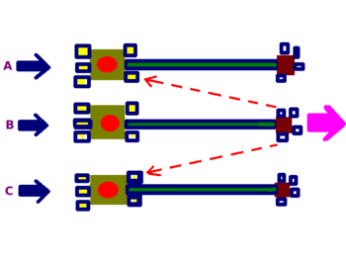](http://en.wikipedia.org/wiki/File:Lateral_Inhibition.png)

Lateral inhibition increases the [contrast](http://en.wikipedia.org/wiki/Contrast_(vision)) and sharpness in visual response of red color. In the [Mach bands](http://en.wikipedia.org/wiki/Mach_bands) illusion, lateral inhibition makes the darker area falsely appear even darker and the lighter area falsely appears even lighter

Somatosensory: 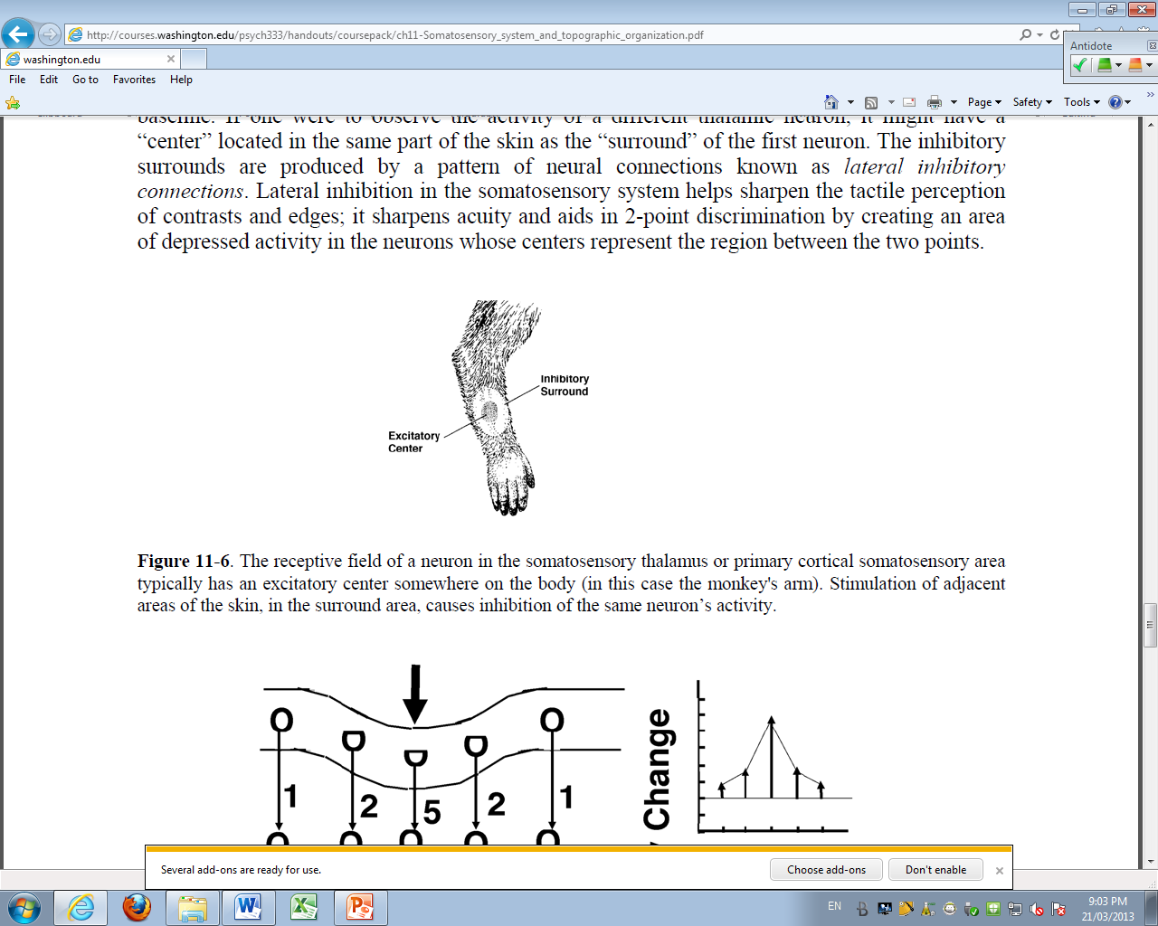 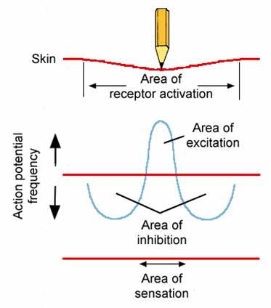

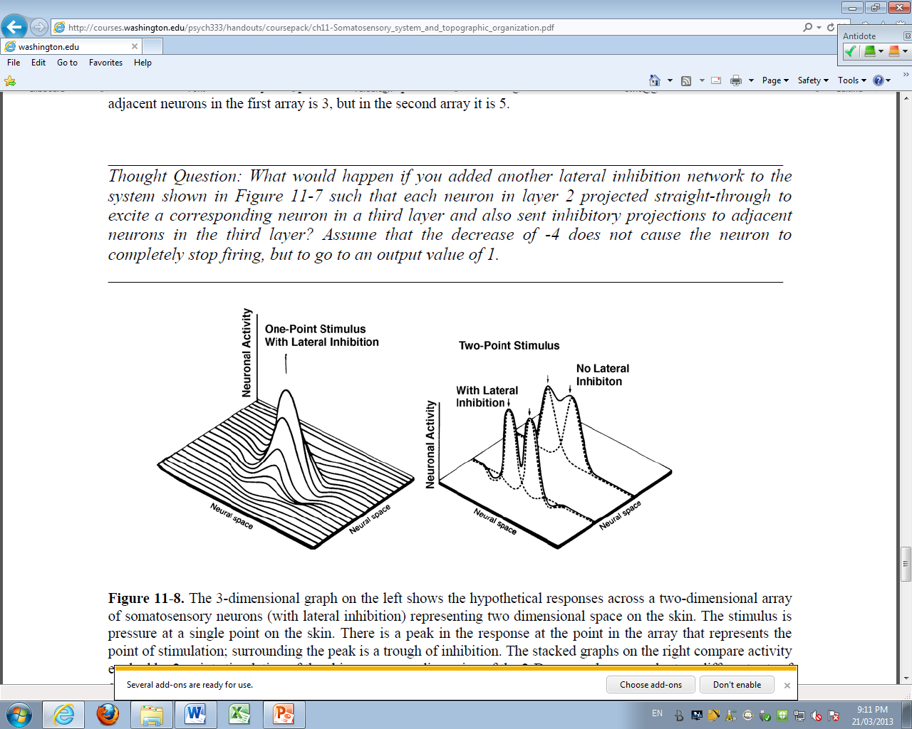

Auditory:

If a sound is to loud or if one want to focus his attention only on one sound.

Receptor Field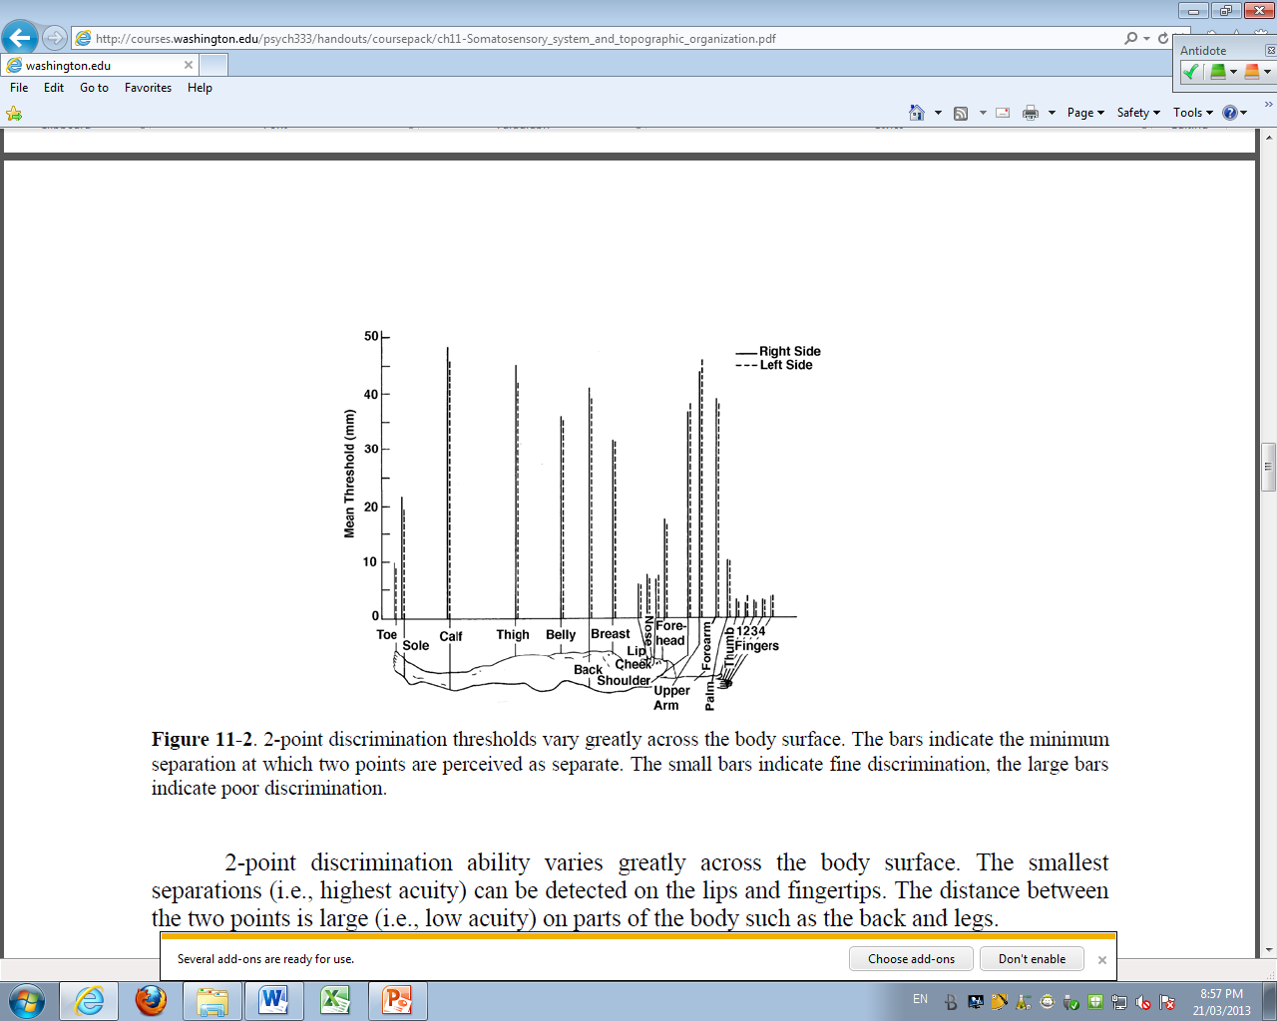

Neurons in the somatosensory cortex have receptive fields that vary in size depending on body location. Areas of the body with smaller receptive fields occupy larger cortical areas and provide greater acuity, as measured by *2-point discrimination thresholds*.

The two-point discrimination threshold is a measure of the smallest detectable distance between two points at which pressure is applied.

Perception Masking

Auditory masking occurs when the perception of one [sound](http://en.wikipedia.org/wiki/Sound) is affected by the presence of another sound.

Sensory sensitivity

Factors that affect sensory sensitivity are:

* Frequency of stimuli (Neurons can follow repeated odor pulses at frequencies of up to 10 Hz odour must be rapidly inactive : this is the prerequisite for high sensitivity).
* Adaptation (see course)
* Masking (see course)
* Temporal integration (different fraction of second between left vs right hear, base for spacialisation🡪 cross-correlation (left and right hear correlated or not).
* Spatial integration
* Internal noise.

Hearing – Vision – Touch in Neural processing 4, slide 5, 23 - 5, slide 2, 3, 4, 8, 9

Different levels of processing

Ex of olfactory system: The interaction between the odorant molecule and his receptor Triggers complex cellular reaction cascades that lead to transduction of chemical signals into a pattern of electrical activity conveyed to the brain for further processing :

* The signal from the receptor goes to the glomeruli inside the olfactory bulb, and the output is conveyed to cortical and sub-cortical areas.
* The activity of neurons in higher brain areas is not only modulated by odors but also by variable behaviors (This is a high level processing).

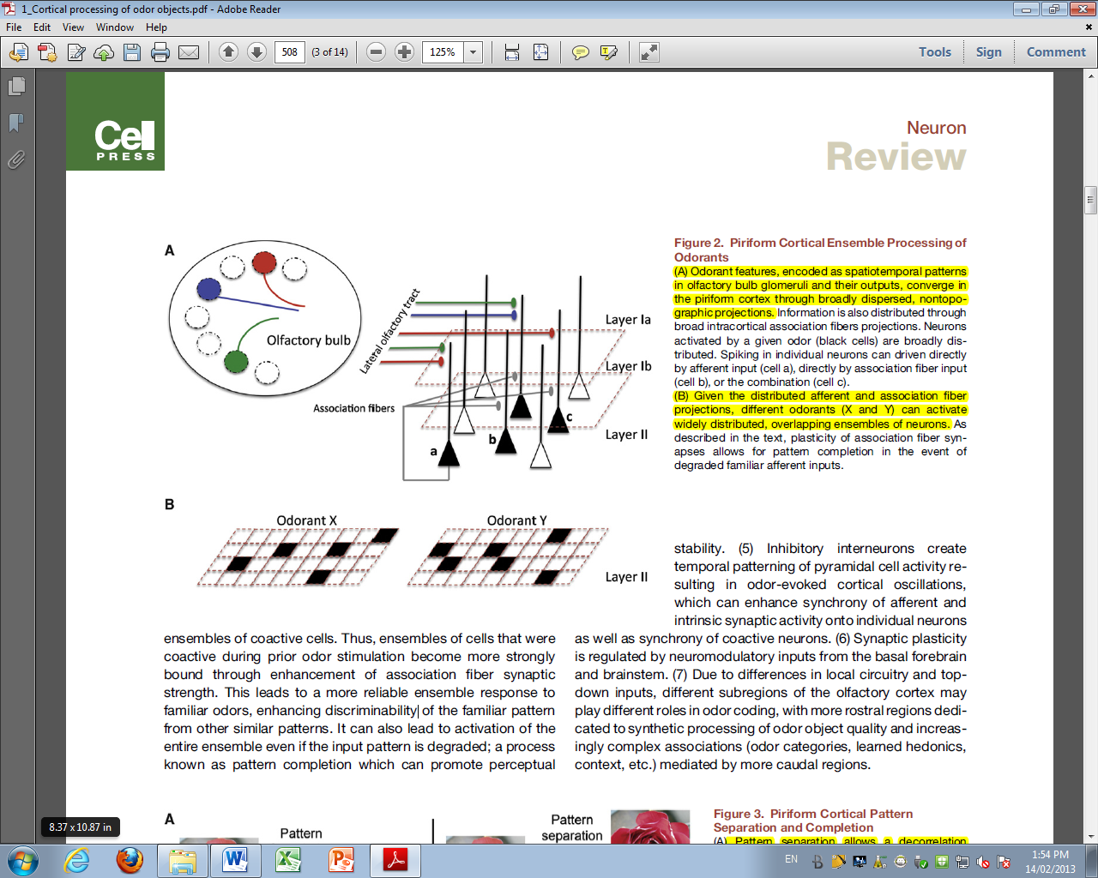

* Piriform cortex performs pattern of separation and completion
* Pyramidal cells that do not respond directly to stimulation of individual glomeruli, do respond when specific combinations of glomeruli are activated = Auto associative connection
* Piriform cortex is susceptible to run-away excitation and seizure activity: Thus, synaptic inhibition plays the role of managing the sensitivity of the circuit.

Ex of visual system (4, slide 11)

Temporal resolution in hearing, allows distinguishing voice coming from left or from right.

Spatial resolution is what allows parallel processing in Vision: sharpening color, motion, shape and depth.